Utility Manual:   
System Maintenance

| May-20 |

**Document Overview**

**Documentation Goals**

This documentation is intended to provide instruction for the ***System Maintenance Utility****.*

**Documentation Disclaimers**

* Teach a user how to utilize the System Maintenance Utility.
* Provide instructions for using the utility to back up and restore databases.
* Provide instructions for using the utility to review old backup files and help determine if they should be deleted or archived.

**Table of Contents**

**Overview of the System Maintenance Utility** 3

**Warning!** 3

**Initial User Options** 4

Section One: Security 4

User Login 4

Security Options - Messages 4

Security Options – Backup Size Estimation 4

Section Two: Choice of Activity 5

Warning 5

System Maintenance Activities 5

**Database Backup and Restoration** 6

Database Backup 6

Backup File Names 7

Database Restoration 7

**Environment Backup and Restoration** 8

Environment Backup 8

Environment Backup Types 9

Environment Restoration 9

**File Utility Options** 10

Make Archive Copy of Backup File 10

Delete a Backup File 11

Archive and Delete Simultaneously 13

**Capacity Information** 14

**Status Indicator and Help Sections** 15

Processing Status Indicator 15

Context-Sensitive Help 15

**Quit and Execute Buttons** 15

Execute 15

Quit 15

# **Overview of the System Maintenance Utility**

This program is designed to allow users to backup and restore their databases and environments without support/developer assistance.

While it appears complicated, it is designed to allow the user to select a "type" of action and only be concerned with the information needed to perform that action.

It has embedded, context-sensitive help, shows the user the exact status of the actions performed, and writes a log for subsequent review if needed.

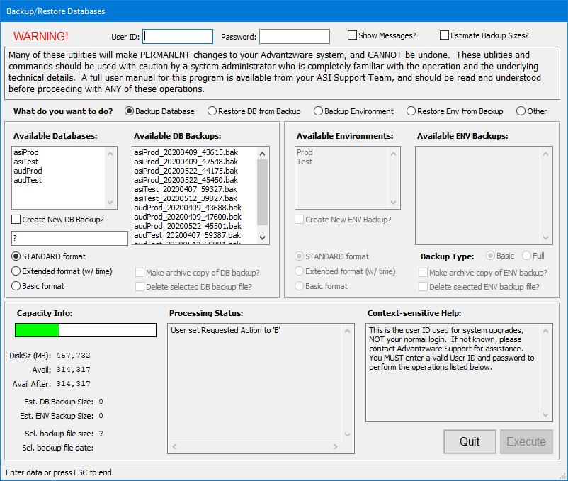

# **Warning!**

Please Note: Many of these utilities will make *permanent* changes to your Advantzware system, and *cannot* be undone. These utilities and commands should be used with caution by a system administrator who is completely familiar with the operation and the underlying technical details.

# **Initial User Options**

## Section One: Security



### User Login

In this section, the user enters a User-ID and Password.  Without valid entries, the “***Execute”*** button at the bottom is not enabled, so no action can be taken, although the user may still review the information presented.



### Security Options - Messages

Immediately next to the login area, the user is presented with two options for further security during the System Maintenance process. Here, the user can optionally choose to have additional messages displayed, which is achieved through the checkbox entitled “***Show Messages”***.



These messages include:

#### Validation Messages

Examples of validation messages include such prompts as ***"Are you sure?"*** when performing changes within this program. These messages are ideal for promoting an added layer of security towards making any changes to your database.

#### Informational Messages

Examples of informational messages include such notices as ***“Success”***. These are useful if a user would like an indication that Database Backups have successfully completed before moving on to a new task.

#### Critical Messages

Critical messages, such as ***“The Database Backup Failed”*** are ALWAYS displayed.  These cannot be disabled by the user.

### Security Options – Backup Size Estimation

Another security option available to the user is a chance to allow the program to estimate that backup file sizes prior to generating the backup files.  This is particularly useful in situations where there is limited disk space available.

These calculations can be time-intensive, so their use is optional in most cases. If a user wishes to run this calculation themselves, they may do so by ticking the checkbox entitled “***Estimate Backup Sizes?”***.



Please Note: If the available disk space is below 100MB, this option will automatically be run by the program itself, and cannot be disabled by the user.

## Section Two: Choice of Activity

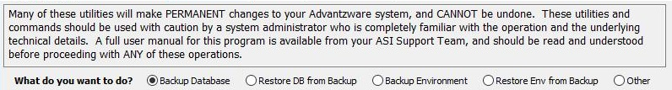

### Warning

In this second section, the user is given a disclaimer that some of the actions that can be performed by this program are irreversible and therefore should only be performed with previous experience.

### System Maintenance Activities

Directly below the disclaimer, the user is given the choice of which activity they wish to perform within the program.

Available Activities are as follows:

|  |  |
| --- | --- |
| Backup Database | This action allows a user to back up their database. |
| Restore DB from Backup | This allows a user to restore their database from a previous backup. |
| Backup Environment | This allows a user to back up the basics of an environment, or to allow the selection of all ENV directories. |
| Restore Env from Backup | This allows a user to restore an environment from a previous backup. |
| Other | These are other file utilities. A user can make archive copies of backups, or delete old backups that are no longer needed. |



The user may choose which activity to use by clicking on the appropriate option buttons. The button that is filled in completely is the current option that the program will run.

When the user chooses on of these options, only the relevant objects are enabled in the program for further use. All other functions will be greyed out and inaccessible in order to maintain system security.

# **Database Backup and Restoration**

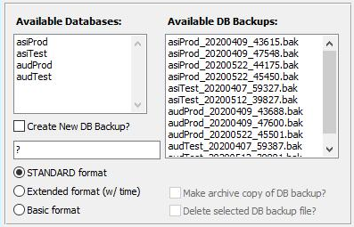

## Database Backup

If the user has decided to back up an existing database, they must select which database they wish to back up from the program’s list of those available to them. In order to choose a database, the user must click on the name of their desired choice within the list of available databases. The database that is chosen will then be highlighted within the list.

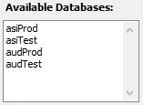

Once a database has been chosen, the user has the two following options:

#### Replace an Existing Backup

If a user chooses to replace an existing backup file, they may then choose which file they wish to replace by highlighting it within the program’s list of Available Database Backups. The file chosen by the user will be highlighted within the list once the user has clicked on their choice.

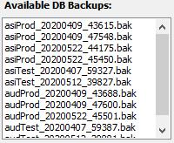

#### Create a New Backup File

If a user chooses to create an entirely new backup file, they may instruct the program to do so by ticking the checkbox entitled “***Create New DB Backup?”*** located below the list of available databases.



### Backup File Names

Backup files are automatically given a suggested name by the program. The user may choose which format they wish the file name to use. Alternatively, the name suggestion can be overridden by the user.

Format Options Include:

|  |  |
| --- | --- |
| Standard Format | Database Name + Date of Backup (YYMMDD) |
| Extended Format | Database Name + Date of Backup + Timestamp |
| Basic Format | Database Name |

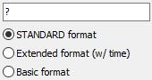

## Database Restoration

If the user has decided to restore a database, they must select which database they wish to restore from the program’s list of those available to them. In order to choose a database, the user must click on the name of their desired choice within the list of available databases. The database that is chosen will then be highlighted within the list.

The user must them choose the Backup file they wish to use. This can be achieved by clicking on their choice within the program’s list of Available Database Backups. The file chosen by the user will be highlighted within the list once the user has clicked on their choice.

# **Environment Backup and Restoration**

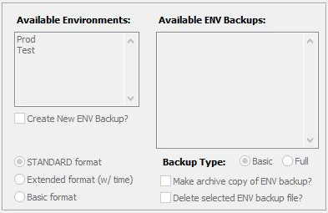

## Environment Backup

If the user has decided to back up an existing environment, they must select which environment they wish to back up from the program’s list of those available to them. In order to choose an environment, the user must click on the name of their desired choice within the list of available environments. The environment that is chosen will then be highlighted within the list.

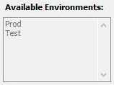

Once an environment has been chosen, the user has the two following options:

#### Replace an Existing Backup

If a user chooses to replace an existing backup file, they may then choose which file they wish to replace by highlighting it within the program’s list of Available ENV Backups. The file chosen by the user will be highlighted within the list once the user has clicked on their choice.

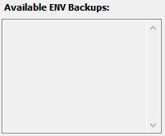

#### Create a New Backup File

If a user chooses to create an entirely new backup file, they may instruct the program to do so by ticking the checkbox entitled “***Create New ENV Backup?”*** located below the list of available environments.



### Backup File Names

Backup files are automatically given a suggested name by the program. The user may choose which format they wish the file name to use. Alternatively, the name suggestion can be overridden by the user.

Format Options Include:

|  |  |
| --- | --- |
| Standard Format | Environment Name + Date of Backup (YYMMDD) |
| Extended Format | Environment Name + Date of Backup + Timestamp |
| Basic Format | Environment Name |



### Environment Backup Types

The user may choose between two different types of environment backup options. This is determined by clicking on the option button of the user’s choice of backup type, located beneath the list of Available ENV Backups.



#### Basic Environment Backup

The Basic environment backup includes only the Programs, Resources, and Override directories of the chosen environment.

#### Full Environment Backup

A Full environment backup includes all the environment’s current directories.

## Environment Restoration

If the user has decided to restore an environment, they must select which environment they wish to restore from the program’s list of those available to them. In order to choose an environment, the user must click on the name of their desired choice within the list of available databases. The environment that is chosen will then be highlighted within the list.

The user must them choose the Backup file they wish to use. This can be achieved by clicking on their choice within the program’s list of Available ENV Backups. The file chosen by the user will be highlighted within the list once the user has clicked on their choice.

# **File Utility Options**

If the user has chosen the “Other” option when selecting which activity they wished the program to perform, they will be presented with two options for both their existing Database Backups and existing Environment Backups.

## Make Archive Copy of Backup File

 

In order to make an archive copy of an existing backup file, the user must select which backup they wish to archive from the program’s list of those available to them.

Please Note: The archived copy of the user’s backups file will be located in the following file path:

<Map drive>:\Backups\Archives\

Database archives will be located in the “Database” folder, and Environment archives will be located in the “Environments” folder. If this file path does not already exist, the program will automatically generate it when creating an archive copy.

#### Database Backup Files

All of the existing Database backups files are listed within the “Available DB Backups” list. In order to choose a backup file to archive, the user must click on the name of their desired choice within the list of available backups. The Database backup file that is chosen will then be highlighted within the database backups list.



The user may then instruct the program to make an archive copy of their chosen Database backup file by ticking the checkbox entitled “***Make archive copy of DB backup?”*** located below the list of available databases.



#### Environment Backup Files

All of the existing Environment backups files are listed within the “Available ENV Backups” list. In order to choose a backup file to archive, the user must click on the name of their desired choice within the list of available backups. The Environment backup file that is chosen will then be highlighted within the environment backups list.



The user may then instruct the program to make an archive copy of their chosen Database backup file by ticking the checkbox entitled “***Make archive copy of ENV backup?”*** located below the list of available environments.



## Delete a Backup File

 

Deleting older backup files is useful if a user needs to gain available disc space for further or future backups.

In order to delete an existing backup file, the user must select which backup they wish to remove from the program’s list of those available to them.

Once executed, the deleted backup files will immediately be removed from the list of backup files available to the user.

#### Database Backup Files

All of the existing Database backups files are listed within the “Available DB Backups” list. In order to choose a backup file to delete, the user must click on the name of their desired choice within the list of available backups. The Database backup file that is chosen will then be highlighted within the database backups list.



The user may then instruct the program to delete their chosen Database backup file by ticking the checkbox entitled “***Delete selected DB backup file?”*** located below the list of available databases.



#### Environment Backup Files

All of the existing Environment backups files are listed within the “Available ENV Backups” list. In order to choose a backup file to delete, the user must click on the name of their desired choice within the list of available backups. The Environment backup file that is chosen will then be highlighted within the environment backups list.



The user may then instruct the program to delete their chosen Database backup file by ticking the checkbox entitled “***Delete selected ENV backup file?”*** located below the list of available environments.



### Archive and Delete Simultaneously

The user may choose to both create an archive copy of a backup file and delete the file from their list of available backups at the same time. This is useful when a user wishes to clean up their list of available backups to restore files within the System Maintenance program, but still wishes to have copies of older databases available for the future.

This can easily be done by ticking the checkbox entitled “***Make archive copy of “” backup?”*** and the checkbox entitled ***“Delete selected “” backup file”*** at the same time before executing the program. These checkboxes are located below the list of available environments in both the Database and Environment section of the user’s screen.

 

Choosing to do this simultaneous action will result in both an archived copy created in the Archive file path, and the backup file being removed from the list of backup files currently available to the user.

# **Capacity Information**

The “Capacity Info” section displays disc space and file sizes to the user so that they can better choose how to execute their file maintenance while using this program.

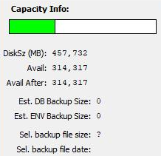

#### Disc Size

The first three pieces of information displayed in this section are the total size of the user’s disc, the currently available space on that disc, and the amount of available space that would remain after a new backup is created.



#### Estimated Backup Size

These two data messages are displayed when either the user has opted to display the estimate of the backup files sizes prior to generating the backup files (by ticking the checkbox entitled “***Estimate Backup Sizes?”*** in the Security Options section), *or* if the available disk space is below 100MB.

This section will display the estimated file size of either the Database Backup file, or the Environment Backup, depending on which the user has selected from the lists of Available Databases or Available Environments.



#### Backup File Size

The final two pieces of information displayed for the user in this section are shown if the user has selected a file within either the “Available DB Backups” or “Available ENV Backups” lists. It allows the user to see how large the currently selected back file size is, as well as the date it was made.

This information is useful when determining when or if a backup file could be considered for archival or deletion.



# **Status Indicator and Help Sections**

## Processing Status Indicator

The Processing Status section of the program screen is a “moving history” of every action performed during the session. Every entry shown here is duplicated into a log file which is saved for later review.

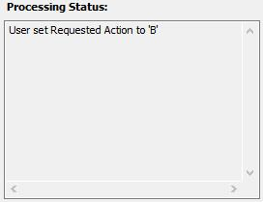

## Context-Sensitive Help

This section of the program displays helpful text for every control on the screen. It is activated when the user enters a field or control.

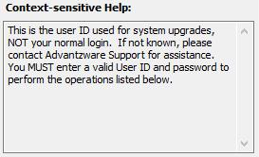

# **Quit and Execute Buttons**

## Execute

When a user clicks the “***Execute”*** button, the system will validate whether or not sufficient information has been entered in order to perform the requested operation. If everything has been done properly, the program will then perform the selected action.

## Quit

The “***Quit”*** button will exit the program. (Note: No actions will be executed at this time.)

